Steel Europe
October 8, 2019
Page 1/3

thyssenkrupp Steel Europe, Equinor and Open Grid Europe to conduct joint feasibility study to advance production of climate friendly hydrogen

Steel producer thyssenkrupp Steel Europe, Norwegian-based broad energy company
Equinor and natural gas transmission system operator Open Grid Europe have launched a joint feasibility study to explore the decarbonized production and supply of “blue” hydrogen from natural gas to Germany’s largest steel plant in Duisburg.

The study’s premise will be the production of hydrogen from natural gas and permanent offshore storage of carbon dioxide accrued in the process, potentially in the Equinor-operated “Northern Lights” storage facility project on the Norwegian shelf. The study will evaluate several options for sourcing and transport of hydrogen to the thyssenkrupp site as well as options for transport and storage of carbon dioxide. Open Grid Europe will add their knowledge in transmitting and transporting gases to the study.

“We consider hydrogen the key to a climate-friendly future. We therefore also welcome the German government’s intention to finalize a national hydrogen strategy,” says Dr Arnd Köfler, member of thyssenkrupp Steel Europe’s Executive Board responsible for production. “In the long-run, our goal will be to increase usage of hydrogen produced from renewable energies.”

Equinor recognizes the importance of hydrogen in the transition to a low carbon society. “New markets are opening, new technologies are emerging and we wish to grasp these opportunities,” says Stephen Bull, Senior Vice President Wind and Low Carbon Solutions at Equinor. “We are exploring several new business opportunities by reforming natural gas to hydrogen, while capturing and storing the CO₂ offshore, as a potential way to help our customers in the power, industry, transportation and heating sectors to meet future climate targets.”

“Hydrogen is a real chance to reach climate neutrality! To exploit the potential we have to develop the hydrogen technology and viable business models across the whole value chain. Politics should encourage this with a legal and regulatory framework supporting the climate protection goals”, says Dr Jörg Bergmann, Chairman of the Board of Management of Open Grid Europe.

thyssenkrupp Steel Europe is evaluating potential ways to ensure sufficient hydrogen supply for the conversion of its steel production to reach thyssenkrupp’s goal of becoming a climate neutral company by 2050. The company is currently pursuing two technological routes: Avoidance of carbon dioxide emissions by injecting hydrogen instead of coal into its blast furnaces and use of hydrogen to produce direct reduced iron is paralleled by Carbon2Chem. Carbon2Chem is a carbon capture and utilization approach, which converts cogeneration gases to valuable and sustainable chemicals based on thyssenkrupp Industrial Solutions’ alkaline water electrolysis and downstream process competence.

About thyssenkrupp Steel Europe
thyssenkrupp Steel Europe is one of the world’s leading suppliers of carbon steel flat products. With around 27,000 employees, the company supplies high-quality steel products for innovative and demanding applications in a wide variety of industries. Customer-specific material solutions and services around steel complete the range of services. With a production volume of approximately 12 million tons of crude steel annually, thyssenkrupp Steel is the largest flat steel producer in Germany.
https://www.thyssenkrupp-steel.com/en/

About Equinor ASA
Equinor is an international energy company, Europe's second largest gas supplier and the largest operator of offshore gas and oil production facilities. A rapidly growing portfolio in the offshore wind and solar energy sectors marks Equinor’s evolution to a broader energy company. Equinor's current offshore wind portfolio can supply more than one million European homes with renewable energy. Equinor has been the world leader in carbon capture and offshore storage since the 1990s.
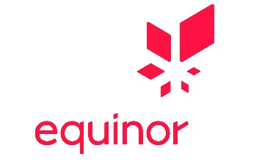
https://www.equinor.com/

About Open Grid Europe
With a pipeline network of around 12,000 kilometres in length, Open Grid Europe is one of Europe’s leading transmission system operators. 1,450 employees provide safe, customer-focused gas transportation throughout Germany
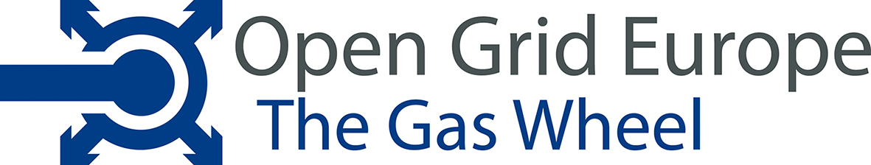
www.open-grid-europe.com

Contact:
thyssenkrupp Steel Europe AG
External Communications
Nils Pfennig
T: +49 203 52 - 28216
nils.pfennig@thyssenkrupp.com
www.thyssenkrupp-steel.com

