Steel Europe
01.12.2016
Page 1/1

At the top of the recycling quota: More than 90 percent of steel packaging was eco-friendly recycled

Up to 90.7% of the tinplate packaging consumed in Germany was utilized in 2015. The quota is 92.9% with respect to the consumption quantities from private households, which represent approximately 85% of the total usage. Thus, now as before, packaging steel (tinplate) is at the top of all comparable packaging materials. The latest figures of the “Recycling Balance Sheet for Packaging”, which have now been presented by the Gesellschaft für Verpackungsmarktforschung (gvm), reflect this. The new figures, which “distinguish consistently...between material and energy utilization” also prove that packaging steel is utilized almost completely, while most other packaging materials require some significant percentage of energy utilization.

As compared to the previous year, the total German consumption of packaging steel increased by approximately 3% to the current 505,800 tonnes. Accordingly, the utilization quota achieved represents a continuation of the recycling quantities of the previous year. The decline of the quota as compared to the previous year’s value by 2.4 percentage points is in part a consequence of the recalculation of utilization quantities from the different collection systems and recording methods due to the 7th amendment of the packaging directive, which has been in effect since 2015. According to gvm, the newly-revised directive caused the omission of individual returns and a decline in industry solutions as compared to the previous year. The motivation for the amendment was explicitly that “loopholes should be closed soon”, which had developed in these exceptional areas of the packaging directive (PM 0873/14 of the BMUB on 04/30/2014).

“Even after the readjustment of the calculation principles, the material utilization of packaging steel remains stable at more than 90%” asserts Dr. Peter Biele, CEO of thyssenkrupp Rasselstein GmbH, Germany's only tinplate manufacturer. “Thus our material considerably exceeds the legally-required threshold of the 70% utilization quota. We welcome the political efforts to present a packaging law that will further strengthen closed loop recycling management.”

Biele, who is being responsible for Packaging Steel since October 1, 2016, sees the steel company's extensive commitment to closing the cycle of potential recyclables as one important reason for the long-term high utilization. “We take product responsibility very seriously, also with an eye to the further value chain. With the establishment of the DWR – Deutsche Gesellschaft für Weißblechrecycling mbH and substantial participation in the non-profit company Kreislaufsystem Blechverpackungen Stahl GmbH (KBS), thyssenkrupp is making an active contribution to the recycling both of privately-consumed steel packaging and commercially-produced quantities and ensuring proper, goal-oriented return to steel production.”

The magnetic property of steel allows a largely pure separation of steel packaging in all sorting processes. “We very much welcome the function of the dual systems for the assurance of a comprehensive collection and return of packaging. Nevertheless, packaging steel is also identified reliably and is not lost in all other disposal systems” explains DWR CEO Andreas Knein.

About us:
In Andernach, Rhineland-Palatinate, thyssenkrupp produces approximately 1.5 million tonnes of packaging steel each year. In this largest location of its type worldwide, thyssenkrupp rolls steel to an extremely thin 0.100 mm thickness and finishes the surface with tin or chrome. Nearly all of the company's output is shipped to packaging producers around the world. In addition to cans for food and pet food, packaging steel is used for beverage and aerosol cans, containers for chemical and technical goods, as well as crown seals and twist-off tops. thyssenkrupp employs approximately 2,400 people in Andernach.

Attachment
Tables “Tinplate Packaging Consumption” and “Utilization Quotas for Tinplate Packaging (source: GVM Gesellschaft für Verpackungsmarktforschung, Recycling Balance Sheet for Packaging. Reporting year 2015, 23rd edition, Mainz, October 2016, p. 57 - 63)

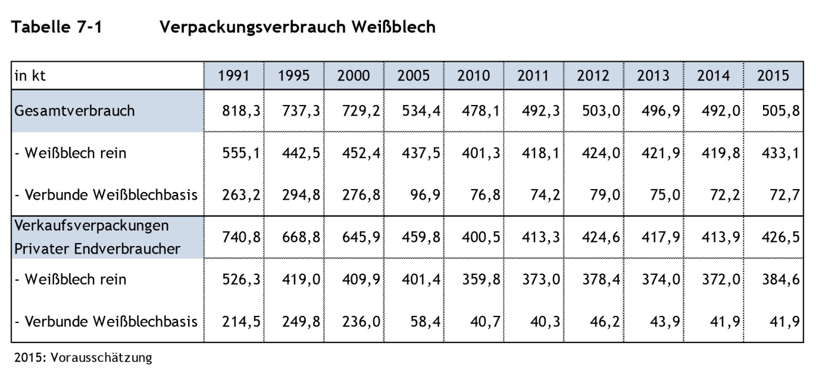

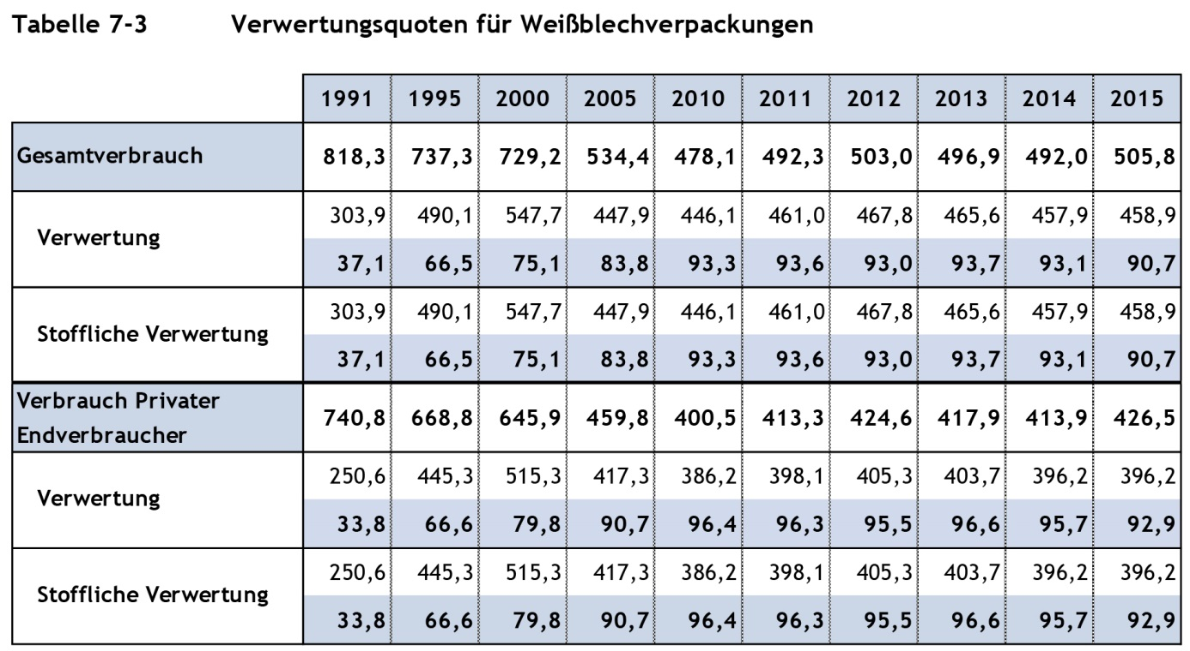

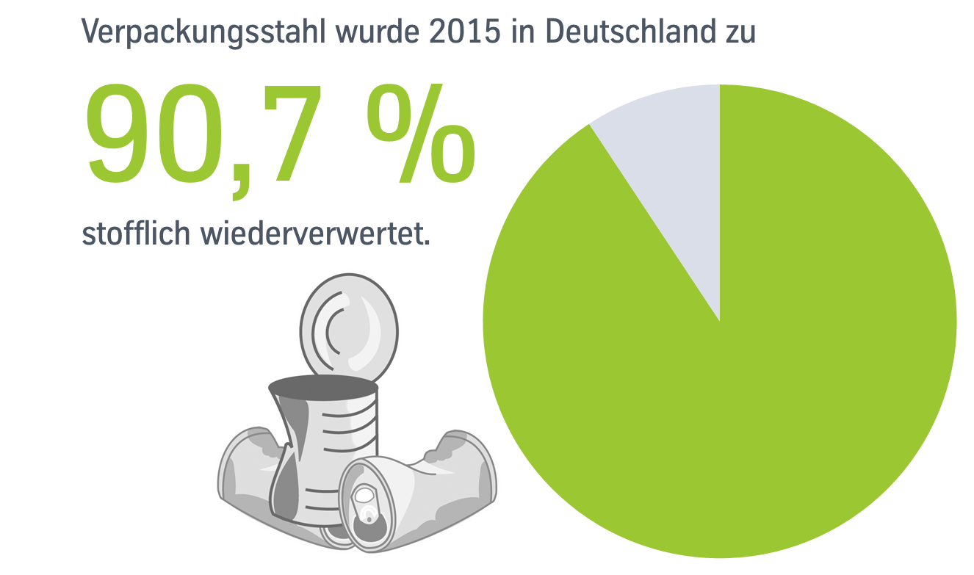

Contact:
thyssenkrupp Steel Europe AG thyssenkrupp Rasselstein GmbH
Erik Walner Volker Lauterjung
Head of Media Relations Head of Communications
T: +49 203 52 - 45130 T: +49 2632 3097 - 2875
erik.walner@thyssenkrupp.com volker.lauterjung@thyssenkrupp.com
www.thyssenkrupp-steel.com

Company blog: https://engineered.thyssenkrupp.com

